**Hunter/Gatherer**

My idea is a game in which the player and the enemy are both trying to eliminate each other with guns. Similar to a twin stick shooter, the player can move independent of where the gun is aiming.

The enemy has three main behaviours and two sub-behaviours.  
The main behaviours are:  
1) If the enemy can’t see the player, it will travel to the player’s last known position, then “search” (or wander)  
2) If the enemy can see the player it will travel toward the player’s position and then transition to the sub-behaviour  
3) If the enemy’s health drops below a certain level, the enemy will actively avoid the player (aka run away) until it comes within range/sight of a health pack and then transitions to the sub-behaviour

The sub-behaviours are:  
1) If the enemy can see the player and is within a defined range of the player, the enemy will attack and attempt to keep the same distance. This allows the player to either push the enemy away or lose it around a corner/wall  
2) If the enemy’s health is below a certain percentage and it comes within range/sight of a health pack then it will move toward the health pack and attempt to collect it. If the health pack restores health above the defined level then the enemy will transition to either main behaviour 1 or 2.

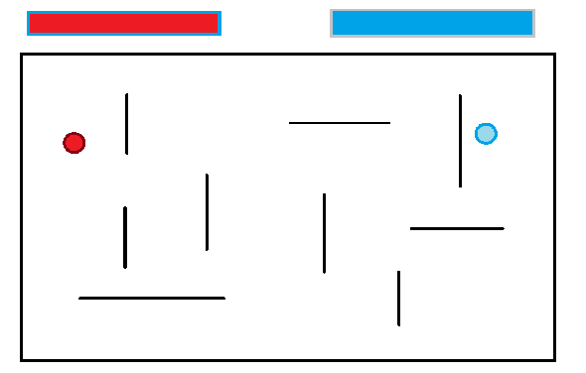

The pathfinding technique would be A Star. The map is randomly generated, in that it has a range of obstacles that are placed around the map as per the reference image above. I prefer A Star over Dijkstra only because I personally prefer the wander behaviour of A Star along a node graph with diagonal vertices.  
Technically Dijkstra would provide a faster path for the enemy, but it also wouldn’t look “lost” when it can’t find the player, so I prefer A Star.

I think that I could better use a Blackboard instead of only using a FSM and Transitions to make reading and assigning behaviours a little easier. Really, I’m unsure because I feel as though while I understand the concept I’m still weak on how to execute it. As it stands the concept is fairly basic, but I’m not over the topic enough to execute my vision.

This topic is quite challenging and is delivered in a huge chunk so getting my head around it has been difficult. I think I’ve watched about 3 hours of YouTube videos on the topic to flesh it out at home but it still doesn’t make a lot of sense. As such, I’m not able to execute my plan and will have to satisfy the basic requirements of the unit. I hope that I can return to this in future, maybe using Unity and C#, and maybe create the game there.